**CODE:**

#reading from a file

data = read.csv("data.csv",header = FALSE, sep = ",")

data=as.numeric(data)

x=mean(data, na.rm = TRUE)

print(x)

**OUTPUT:**

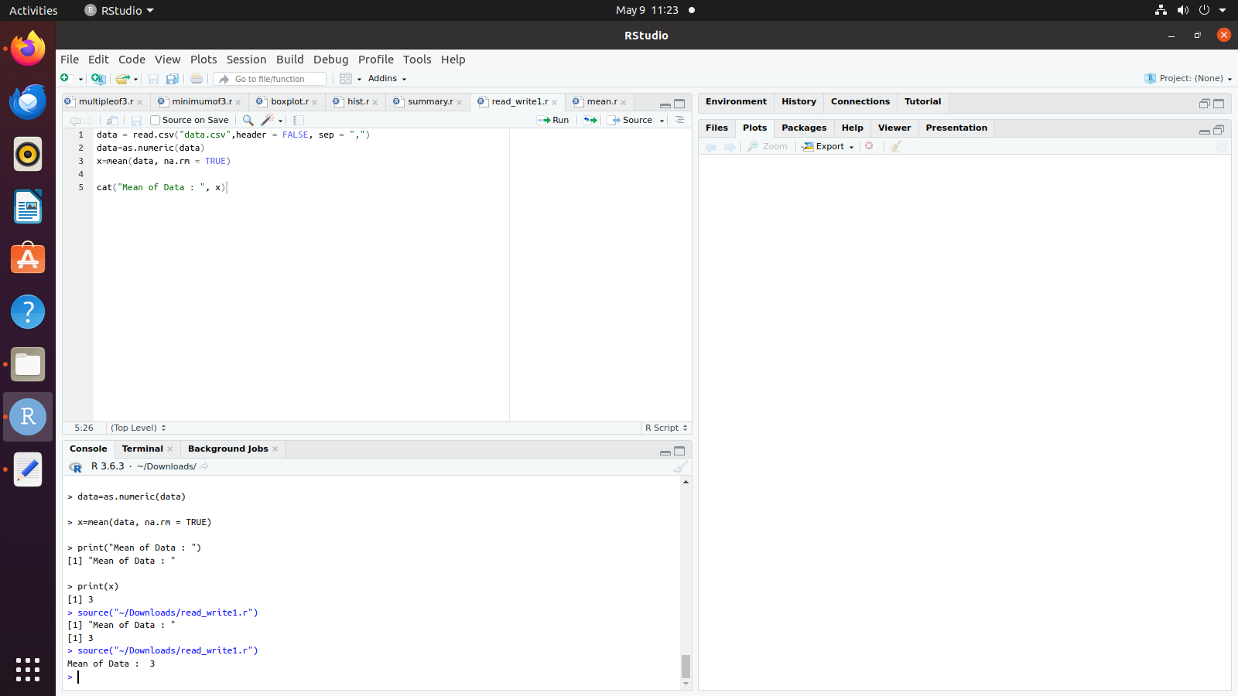

**CODE:**

#Writing to a file

rating <- 1:4

animal <- c('koala', 'hedgehog', 'sloth', 'panda')

country <- c('Australia', 'Italy', 'Peru', 'China')

avg_sleep_hours <- c(21, 18, 17, 10)

super_sleepers <- data.frame(rating, animal, country, avg_sleep_hours)

data=super_sleepers;

write.table(super_sleepers, "data.txt")

example <- read.table('data.txt', header = TRUE, sep = " ")

x=mean(as.numeric(example$rating),na.rm = TRUE)

print(x)

**OUTPUT:**

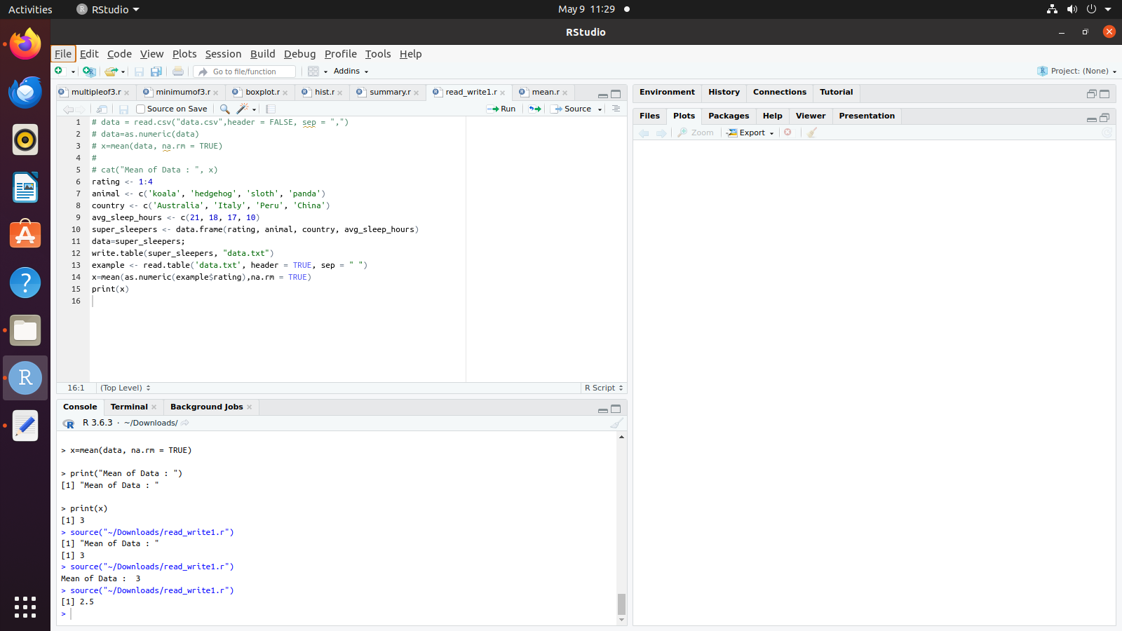

Data.txt

